Seattle Housing Authority

will be accepting applications for a chance to receive a Housing Choice Voucher starting Jan 17th, 2024!



Please come to The Neighborhood Center on Jan 17th, 2024, if you would like assistance with the application process!

On Wednesday, January 17, 2024, the Seattle Housing Authority will open application to families and individuals for a chance to receive a Housing Choice Voucher (formerly known as a Section 8 voucher), which provides rental assistance for people with low incomes to rent from landlords throughout the Seattle rental market.

The opportunity to apply for a chance to receive a voucher will be ongoing.

Event Date: Jan 17th, 2024

Event Time: 9 am -12 pm

Location: The Neighborhood Center

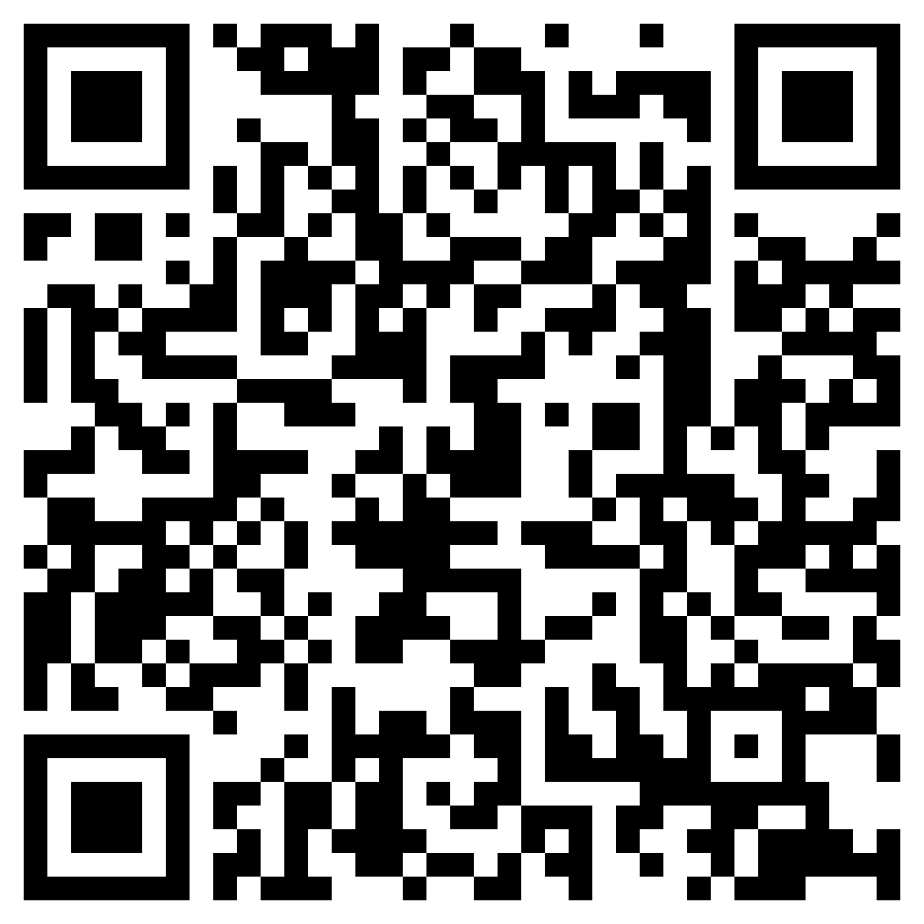**For more information about SHA HCV and the application process, please scan the QR code below!**